Name : Y.Rami Reddy
ID : 11602716
Email : ramireddy123437@gmail.com
Section : K1609
Roll no : B37
Questions :12 and 15
Githublink:
https://github.com/Ramireddy07/Os_Project_B37_K1609_12-and-15

Question 12.
Implement the multi-level feedback queue scheduling algorithm by considering the following diagram: You can use the code of others to implement Roud-Robin, and FCFS but implement aging by your own self.
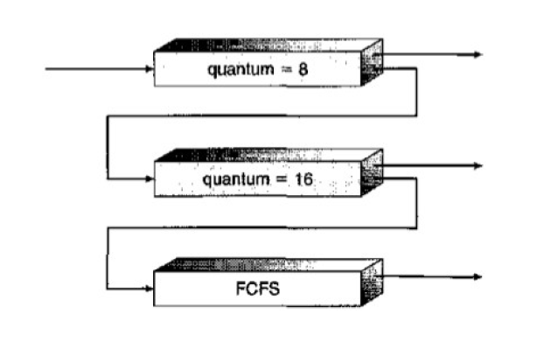
Description:
ROUND ROBIN SCHEDULING:
The question can be solved by using Round Robin Scheduling.
■ A Time Quantum is associated to all processes
■ Time Quantum: Maximum amount of time for which
process can run once it is scheduled.
■ RR scheduling is always Pre-emptive.

MULTILEVEL FEEDBACK ALGORITHM:
■ Multilevel Feedback Queue
■ If a process is taking too long to execute. Pre-empt
it send it to low priority queue.
■ Don’t allow a low priority process to wait for long.
■ After some time move a least priority process to
high priority queue
→ Aging

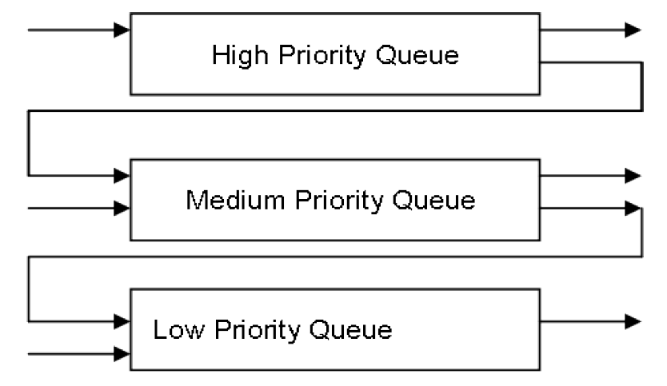

FIRST COME FIRST SERVE
In the "First come first serve" scheduling algorithm, as the name suggests, the process which arrives first, gets executed first, or we can say that the process which requests the CPU first, gets the CPU allocated first.
- First Come First Serve, is just like FIFO(First in First out) Queue data structure, where the data element which is added to the queue first, is the one who leaves the queue first.
- This is used in Batch Systems.
- It's easy to understand and implement programmatically, using a Queue data structure, where a new process enters through the tail of the queue, and the scheduler selects process from the head of the queue.
- A perfect real life example of FCFS scheduling is buying tickets at ticket counter.

Complexity:
Round Robin Scheduling-- O(1)

Code snippet:
#include<stdio.h>
typedef struct{
int pid, at, bt, pri;
int q, ready;
int queue;
}process_structure;
void findWT(int p[], int m,int bt[], int wt[], int quant){
int rem_bt[m],i;
for ( i = 0 ; i < m ; i++)
rem_bt[i] = bt[i];
int t = 0;
while (1)
{
int done = 1;
for ( i = 0 ; i < m; i++)
{
if (rem_bt[i] > 0)
{
done = 0;
if (rem_bt[i] > quant)
{
t += quant;

rem_bt[i] -= quant;
}

else
{
t = t + rem_bt[i];

wt[i] = t - bt[i];

rem_bt[i] = 0;
}
}
}

if (done == 1)
break;
}
}
void findTurnAroundTime(int processes[], int n,int bt[], int wt[], int tat[]){
int i;
for (i = 0; i < n ; i++)
tat[i] = bt[i] + wt[i];
}
void findavgTime(int processes[], int n, int bt[],int quant){
int wt[n], tat[n], total_wt = 0, total_tat = 0,i;
findWT(processes, n, bt, wt, quant);
findTurnAroundTime(processes, n, bt, wt, tat);
printf("Processes Burst time Waiting time Turn around time\n");
for (i=0; i<n; i++)
{
total_wt = total_wt + wt[i];
total_tat = total_tat + tat[i];
printf(" %d\t\t%d\t\t%d\t\t%d\n", i+1 ,bt[i] ,wt[i],tat[i]);
}
printf("Average waiting time = %f\nAverage turn around time =%f" ,(float)total_wt / (float)n,(float)total_tat / (float)n);
}
int Queue(int t1){
if (t1 == 0 || t1 == 1 || t1 == 2 || t1 == 3){
return 1;
}
else{
return 2;
}
}
void RoundRobin(process_structure process[],int processes[],int size){
int BurstTime[size],pid[size];
int quantum,i;
printf("Enter time quantum:");
scanf("%d",&quantum);
for(i=0;i<size;i++){
pid[i] = process[processes[i]].pid;
BurstTime[i] = process[processes[i]].bt;
}
findavgTime(pid,size,BurstTime,quantum);
}
int main(){
int limit, count, temp_process, time, j, y,ch;
process_structure temp;
printf("Enter Total Number of Processes:\t");
scanf("%d", &limit);
int RoundQueue[limit],RoundSize=0;
int PriorityQueue[limit],PrioritySize=0;
process_structure process[limit];
for(count = 0; count < limit; count++){
printf("\nProcess ID:\t");
scanf("%d", &process[count].pid);
printf("Arrival Time:\t");
scanf("%d", &process[count].at);
printf("Burst Time:\t");
scanf("%d", &process[count].bt);
printf("Process Belongs to which Queue:\n1.Priority Queue\n2.Round Robin\n");
scanf("%d",&process[count].queue);
if(process[count].queue == 1){
printf("Process Priority:\t");
scanf("%d", &process[count].pri);
temp_process = process[count].pri;
process[count].q = Queue(temp_process);
process[count].ready = 0;
PriorityQueue[PrioritySize++] = count;
}
else{
RoundQueue[RoundSize++] = count;
}
}
time = process[PriorityQueue[0]].bt;
for(y = 0; y < PrioritySize; y++){
for(count = y; count < PrioritySize; count++){
if(process[PriorityQueue[count]].at < time) {
process[PriorityQueue[count]].ready = 1;
}
}
for(count = y; count < PrioritySize - 1; count++){
for(j = count + 1; j < PrioritySize; j++){
if(process[PriorityQueue[count]].ready == 1 && process[PriorityQueue[j]].ready == 1){
if(process[PriorityQueue[count]].q == 2 && process[PriorityQueue[j]].q == 1){
temp = process[PriorityQueue[count]];
process[PriorityQueue[count]] = process[PriorityQueue[j]];
process[PriorityQueue[j]] = temp;
}
}

}

}

for(count = y; count < PrioritySize - 1; count++){

for(j = count + 1; j < PrioritySize; j++)

{

if(process[PriorityQueue[count]].ready == 1 && process[PriorityQueue[j]].ready == 1)

{

if(process[PriorityQueue[count]].q == 1 && process[PriorityQueue[j]].q == 1)

{

if(process[PriorityQueue[count]].bt > process[PriorityQueue[j]].bt)

{

temp = process[PriorityQueue[count]];

process[PriorityQueue[count]] = process[PriorityQueue[j]];
process[PriorityQueue[j]] = temp;

}

else{
break;
}

}

}

}

}

printf("\nProcess[%d]:\tTime:\t%d To %d\n", process[PriorityQueue[y]].pid, time, time + process[PriorityQueue[y]].bt);

time = time + process[PriorityQueue[y]].bt;

for(count = y; count < PrioritySize; count++){

if(process[PriorityQueue[count]].ready == 1){

process[PriorityQueue[count]].ready = 0;

}
}
}
RoundRobin(process,RoundQueue,RoundSize);
}

Test Cases:

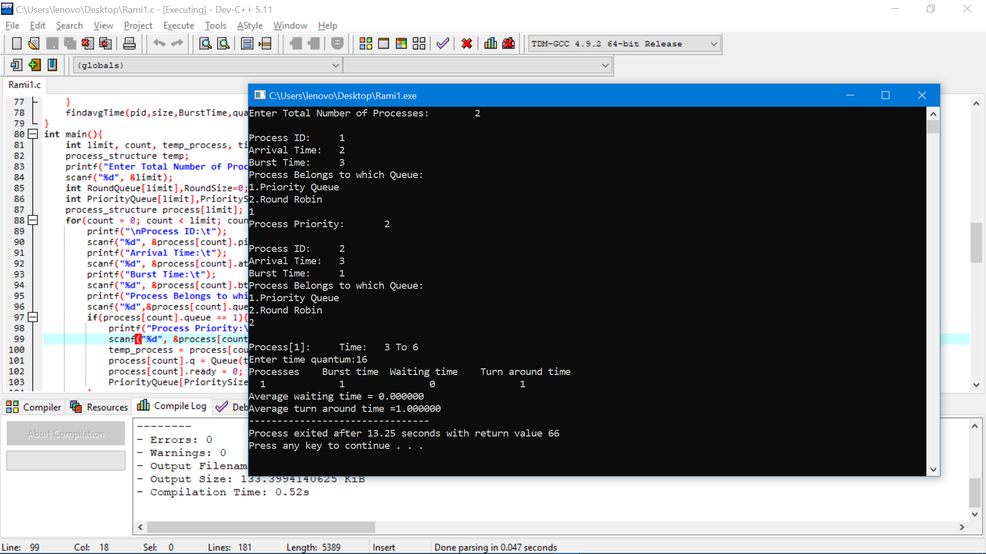

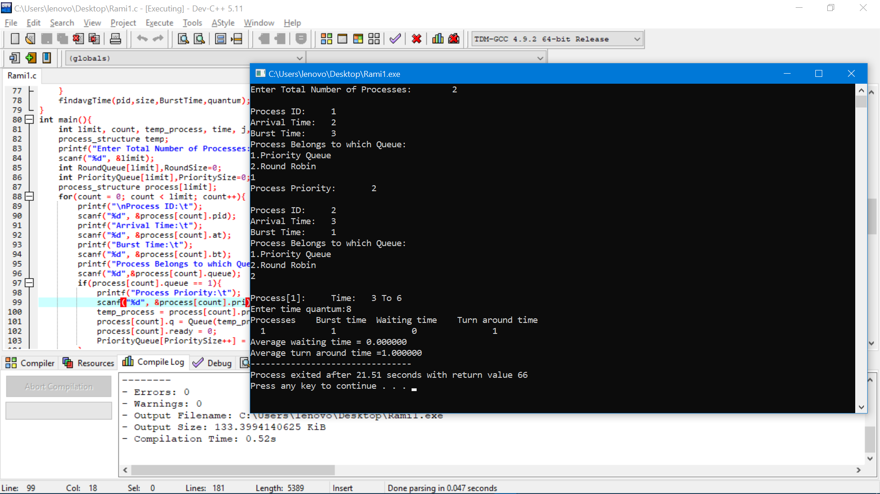

Question 15:

CPU schedules N processes which arrive at different time intervals and each process is
allocated the CPU for a specific user input time unit, processes are scheduled using a
preemptive round robin scheduling algorithm. Each process must be assigned a numerical
priority, with a higher number indicating a higher relative priority. In addition to the
processes one task has priority 0. The length of a time quantum is T units, where T is the
custom time considered as time quantum for processing. If a process is preempted by a
higher priority process, the preempted process is placed at the end of the queue. Design a
scheduler so that the task with priority 0 does not starve for resources and gets the CPU at
some time unit to execute. Also compute waiting time, turn around.
Description:

1)Explanation:
The problem is about scheduling the processes on basis pre-emptive round robin algorithm and each process is assigned with numerical priority. In this problem the priority of lower priority process should be increased ever time its pre-empted so that it is not starving for he resources
2)Algorithm:
In this problem round robin algorithm is used. In round robin algorithm every process have a fixed time Quantum. The process executes for some time and after time quantum is expired another process is executed. And if the process did not complete its execution it will be placed in ready queue so that it will be executed again.
Code Snippet:

#include<stdio.h>
#include<pthread.h>
struct record
{
int p,at,bt,wt,tat,rt;
};

void sortarrivaltime(struct record a[],int processes) //selection sort
{
int i,j;
struct record temp;
for(i=0;i<processes;i++)
{
for(j=i+1;j<processes;j++)
{
if(a[i].at > a[j].at)
{
temp = a[i];
a[i] = a[j];
a[j] = temp;
}
}
}
return;
}

int main()
{

int i,j,processes,time,remain,flag=0,ts;
struct record a[7];
float avgturnaround=0;
printf("Round robin algorithm \n");
printf("Number Of processes");
scanf("%d",&processes);
remain=processes;
for(i=0;i<processes;i++)
{
printf("Enter arrival time and Burst time for processes P%d : ",i);
scanf("%d%d",&a[i].at,&a[i].bt);
a[i].p = i;
a[i].rt = a[i].bt;
}
sortarrivaltime(a,processes);
printf("Enter Time Quantum for each process: ");
scanf("%d",&ts);
for(time=0,i=0;remain!=0;)
{
if(a[i].rt<=ts && a[i].rt>0)
{
time = time + a[i].rt;
a[i].rt=0;
flag=1;
}
else if(a[i].rt > 0)
{
a[i].rt = a[i].rt - ts;
time = time + ts;
}
if(a[i].rt==0 && flag==1)
{
remain--;
a[i].tat = time-a[i].at;
a[i].wt = time-a[i].at-a[i].bt;
avgturnaround = avgturnaround + time-a[i].at;
flag=0;
}
if(i==processes-1)
i=0;
else if(a[i+1].at <= time)
i++;
else
i=0;
}
printf("\n processes\t arrivaltime\t bursttime\t turnaround\t waittime\n");
printf("======================================================================================================================================\n");
for(i=0;i<processes;i++)
{
printf("P%d\t %d\t %d\t %d\t %d\n",a[i].p,a[i].at,a[i].bt,a[i].tat,a[i].wt);
}
avgturnaround = avgturnaround/processes;
printf("Average Turnaround Time : %.2f \n",avgturnaround);
}

Boundary conditions :
The maximum no of process should be less than or equal to 7.
The burst time and the arrival time should not be negative.
The arrival time of all the processes should be in increasing order only.

Complexity:
For sorting the processes according as per arrival time the complexity is O(n).
For sorting the processes as per priority using array the complexity is O(n).
The overall complexity of the program is O(n^2).

Test Cases

